

**Easy Read**

**What to do if you are not happy with your healthcare**

**What is this booklet about?**

We are the Parliamentary and Health Service Ombudsman.

We look into complaints about the NHS in England.

Please answer the questions in this booklet if you want us to look at your complaint.

It will help us decide if we can look at your complaint.

Please phone 0345 015 4033 if you have questions about this booklet.



**Some questions to answer first**

**1. Have you complained to the NHS organisation that gave you care?**

This means, have you told them what you are unhappy about?

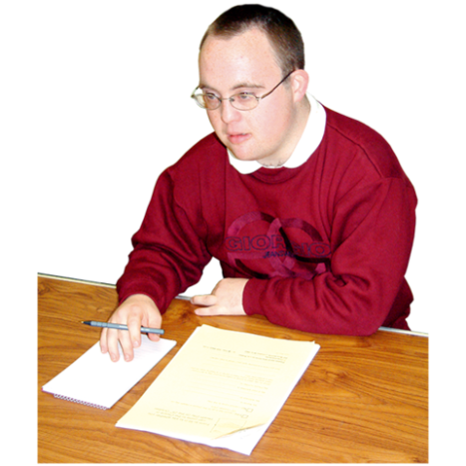

Yes  No 



**2. Did the NHS organisation give you a final answer about your complaint?**



Yes  No 

**If you said no to these questions**

You need to complain to the NHS organisation before you come to us.

This gives the NHS organisation a chance to put things right.



The NHS organisation should give you a final answer about your complaint.

If you are not happy with their final answer you can come to us.

For more information about how to complain to the NHS, look on our website at:



[www.ombudsman.org.uk/  
sites/default/files/Easy_read_Tips_on_making_a_complaint_NHS_lealfet.pdf](https://www.ombudsman.org.uk/sites/default/files/Easy_read_Tips_on_making_a_complaint_NHS_lealfet.pdf)



**3. Have we given you a number for your complaint? It is called a reference number.**

If you have a reference number, please write it here:



**About your complaint**



**4. When did the problem you want to complain about happen?**

Please tell us the date, month and year if you can.



**5. When did you first start to know about the problem?**

For example, was it at the time you got care from the NHS or a little while afterwards?

Please tell us the date, month and year if you can.



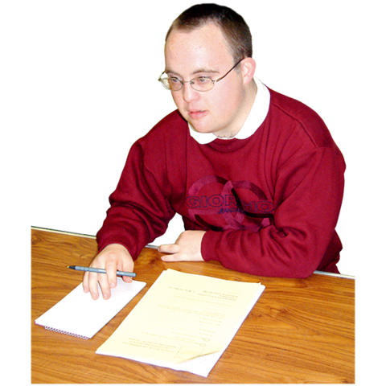

**6. When did you complain to the NHS organisation?**

Please tell us the date, month and year if you can.



**7. You usually have one year to tell us about your complaint.**

Sometimes we can look at your complaint after this, but not often.

If you are coming to us more than one year after the problem started please tell us why.



**Help from the law**

Sometimes people go to court to solve a problem.

Sometimes they go to a type of court called a tribunal.

Usually we cannot look at your complaint if:

* we think it is best for you to go to court or a tribunal
* you have already gone to court or a tribunal
* you plan to go to court or a tribunal.

When you go to court or a tribunal it is called taking legal action.



**8. Are you planning to take legal action about your complaint?**



Yes  No 

If you are, please tell us more about it here:



**Who are you complaining about?**

**9. What is the name and address of the NHS organisation you are complaining about?**





**10. Are you complaining about a certain person? For example, a doctor or nurse?**

Please give us their name if you want to.





**11. Please tell us a bit about your complaint**

Please tell us:

* what happened
* when
* who was involved.





**12. Did the NHS organisation give you an answer to everything you said in your complaint?**



Yes  No 

If they did not answer everything in your complaint please tell us what they missed.



**13. Has the problem you are complaining about made your life hard or caused you any problems?**

Please tell us about any problems it has caused.





**14. If we can look at your complaint, how do you want us to help?**

For example, sometimes we can ask organisations to:

* say sorry
* change the way they do things
* pay you some money if we think they should.

Please tell us what you want to happen.

If we think this can’t happen we will tell you.





**About you (the person   
making the complaint)**



**15. Your first and last name**





**16. Your address and postcode**





**17. Your phone number in the daytime**



**18. Your email address**







**19. How would you like us to get in touch with you?**



Phone



Post

Email



**20. Is there any support you need from us to make your complaint?**

For example, information in easy read or something else?

If there is, please tell us what you need.



**Please sign the form**

Please sign your name below if you are happy for us to:

* look into your complaint
* get all the information we need about your complaint.

We may need to look at your medical records.

Your medical records are notes that the doctor or nurse keeps about you.



**Please write your name here if you agree to this.**



**The date**



**Are you filling in this form for someone else?**

This section means you are filling in this form for someone else who wants to make a complaint.



If you are please tell us this information.



**21. How do you know the person?**



I am their wife, husband, boyfriend or girlfriend



I am their parent or a person who looks after them by law (a guardian)

I am their child



I am their carer

I am someone else.

**22. Why can’t the person tell us about the complaint themselves?**



They are not well enough

They are a child



They can’t do it on their own



They want me to do it

They have died

Something else.

We need to know that they are happy for you to:

* speak to us for them
* see personal information about them and their complaint.

The person you are speaking for should fill in the information if they can.



**If you are filling in the form for someone else please tell us**

**23. Your first and last name**





**24. Your address and postcode**



**25. Your phone number in the daytime**



**26. Your email address**



**Write your name here if you are happy for this person to speak to us**





**The date**





**What to do now**

Pictures by Photosymbols/March 2017

Please email us:

* this form
* a copy of the final letter you got from the NHS   
  about your complaint.

Please **email** them to:

[phso.enquiries@ombudsman.org.uk](mailto:phso.enquiries@ombudsman.org.uk)

Or **post** them to:

Customer Services

Parliamentary and Health Service Ombudsman

Millbank Tower

Millbank

London

SW1P 4QP

Thank you

